# Bechtel Customization

## Overview

This document provides the overview, installation and configuration of rule processing customization developed for Bechtel. The customization performs two functions.

1. Import tag data to eB using pre-formatted excel spreadsheets
2. Execute rules (defines additional relationships based on incoming data) on two events
   1. During tag import
   2. During document creation

## Limitations

It’s assumed that the documents are loaded via bulk load or manual creation. The customization supports both. However, its assumed that tags are only loaded via the import interface. While creating tags via NED or Director is allowed, the rules will not be executed.

## Technical Architecture

The customization consists of three pieces

1. Web Plugin – Provide the interface to import tag spreadsheets. This plugin will expose an import link for import documents.
2. Engine – performs Tag import and execution of rules for both tags and documents
3. Event handler(s) – Invokes the engine for document rule processing

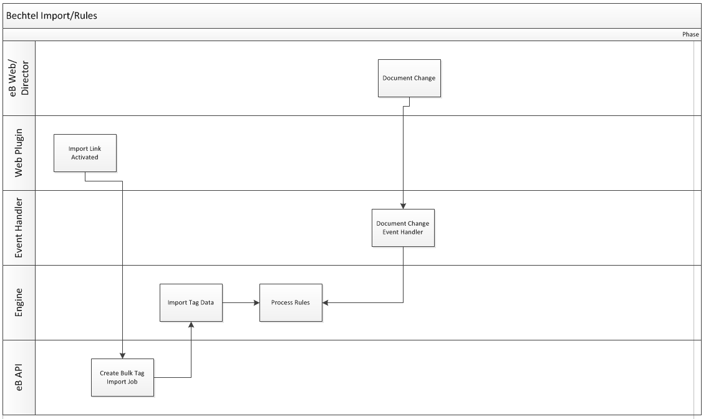

## Column Mappings

Column mappings from the excel spreadsheet to eB is done using a destination enumeration. The current process supports 7 types of column mappings which is indicated in destination attribute for each map. They are

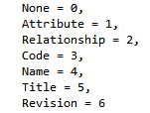

An example of a mapping listed below

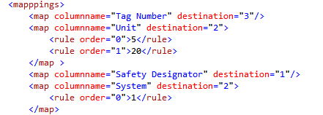

The first line indicate the tag number (destination 3 ) is used as the objects code.

Second line state that the Unit (destination 2 is a relationship) and two rules are executed for this column.

The mapping file also indicates how the import process looks up the template to create the row.

Example below

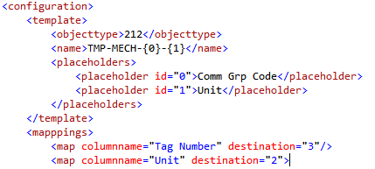

The above example states that the template for the tag is TMP-MECH-<Commodity Group Code>-<Unit>. Import process will replace the placeholders with the values for the row.

## Rules

Each column map can have 0 or more rules attached to it. For example, P&ID column can have a rule that defines how to find the matching P&ID and what relationship template is used to create the relationship.

Example rule is below

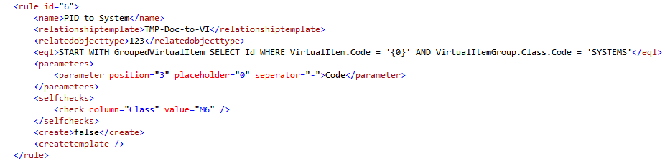

Name describes what the rule is and no other purpose. Relationship template states what relationship template to be used when creating the relationship. The related object type specifies the related object type. The parameterized eql is being used to query the object id.

Parameters node has few options, in above case it tells the parameter is 4th (0 based index) section of the string that is separated by a - .

Selefcheck node will check before executing the rule, and will execute only if it passes. Since this is only for P&ID’s the rule will be executed only if the class = M6.

## File Names

The import mapping files must be named <import template name>_<community name>.xml . For example, if the import template is IMP_MECH and the cimmunity is BechtelTest, the process will look for a config file named “IMP_ELEC_BechTelTest.xml”.

For documents, the process looks for a file called DocumentTemplate_<communityname>.xml

For Rules the process looks for a file called Rules_<communityname>.xml

All files need to be on the engines folder.

## Installation

### Web Plugin

1. Copy the DataImport folder verbatim to Plugins folder in web
2. Copy eB.Plugin.DataImport.dll to Bin folder
3. Append the content of web.config.text to the plugins section of web.config
4. Open the config.xml located in the DataImport folder and make sure the community name is correct

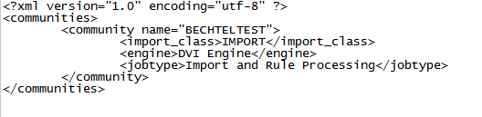

### Event Handlers

Note (if the database is being restored, this step may not be necessary)

1. Execute the “ebph_bechtel_document_changed.sql” script on the database
2. Add the ebph_bechtel_document_changed stored procedure to OnObjectChange event handler hook on SMC

### Engine

1. Copy ClosedXML.dll, eB.Engine.DVI.dll and eB.Engine.DVI.dll.config into server\engines folder
2. Copy all files in config folder to servr\engines folder and make sure they are renamed with the community name (see the config file section above for naming conventions)
3. Execute the jobtype.sql on the eB database ( this may not require on restored databases)
4. Enable the work queue and job type “Import and Rule Processing” on the eB application server